TIEN’S ATM

User Manual

1. Find the file "MaiTienFinalProject.zip" you downloaded, right click on the zip file and select "Extract Here" to extract the application.

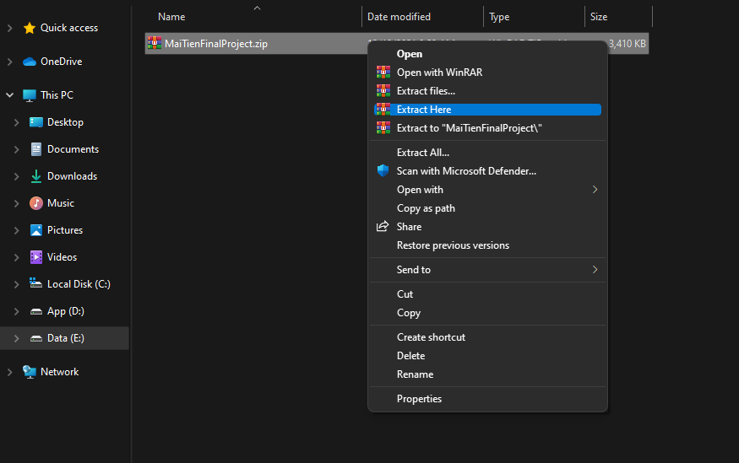

1. After extracting, a folder with the same name as the zip file will appear (image 1). You open that folder, then find and open the python file called "Tien's ATM.py" to start the application (image 2)

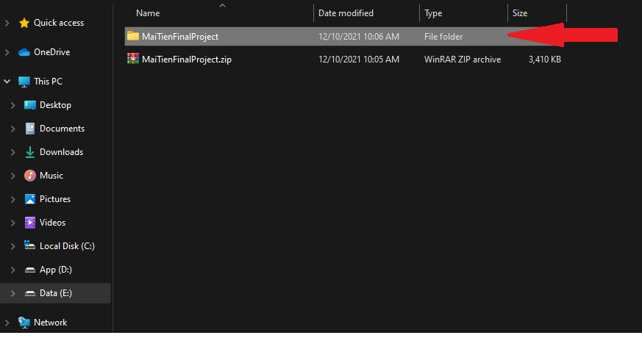

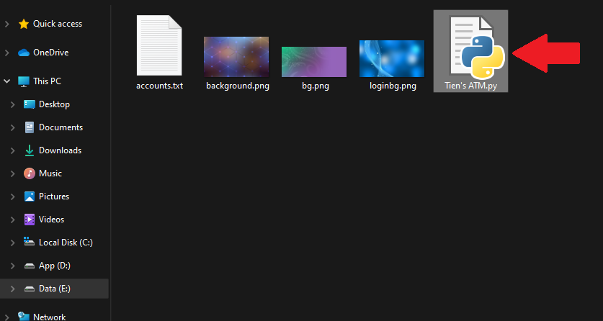

1. The first application screen will be the login window. You will need to enter the correct username and password of your bank account to be able to use the app's further functions.

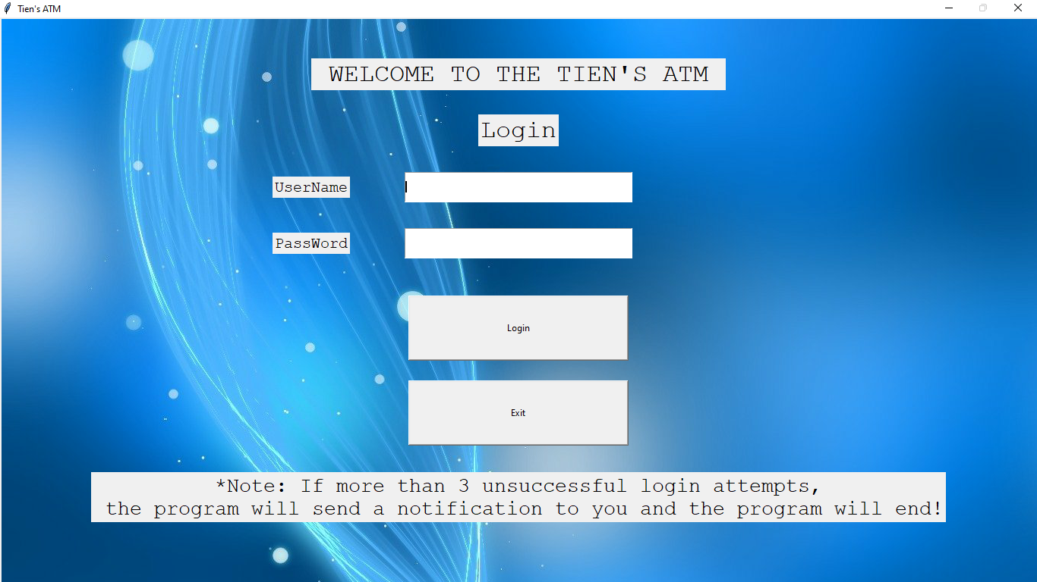

1. After successful login, a "Menu" window will appear including the following 4 main functions:
   1. Check balance: Used to check your current account balance
   2. Deposit: Used to deposit into your account
   3. Withdraw: Used to withdraw from your account
   4. Exit: Used to exit the program

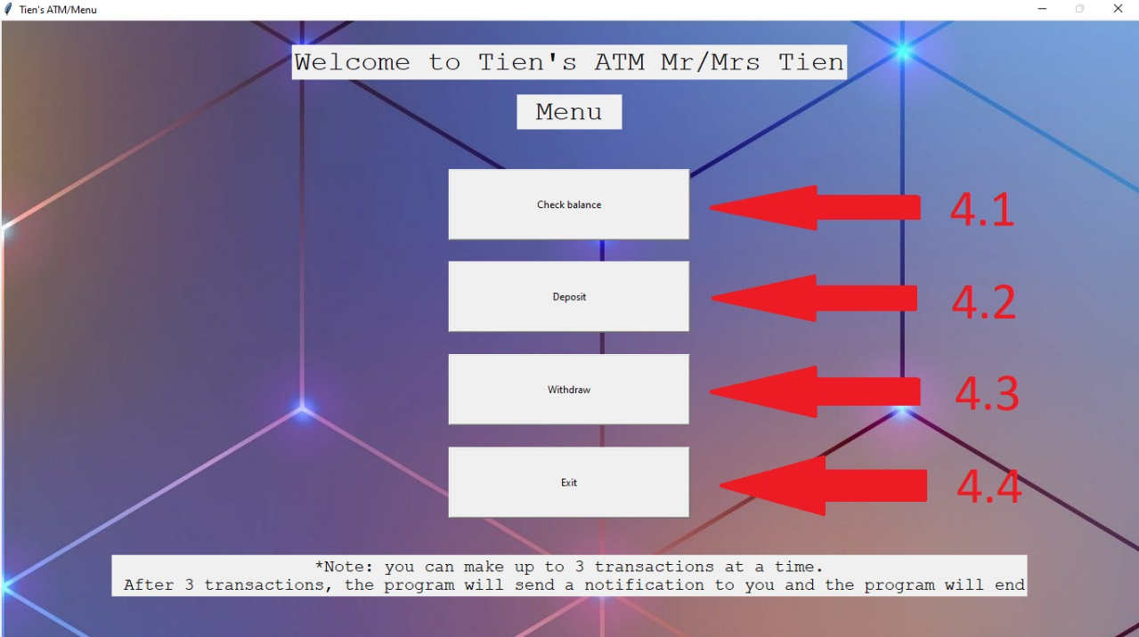

1. The "Deposit" and "Withdraw" windows will ask you to enter the amount you want to make the transaction. Each transaction cannot exceed $2000 and not less than $0. Another note is that the amount you want to withdraw cannot be more than your current account balance.

